Advanced Software Engineering

Final Project

KC easy cars

**Team 11**

1. Devi Vara Prasad Kada (18)
2. Santosh Gandhi Diddi (12)
3. Mourya Praharsha Bobbili (8)
4. Vinay Chandra Vasamsetti (42)

**1.Introduction**

**KC easy cars**

As we know that people travel from one place to another place in search of greater economic opportunity all over the world. They face some problems when they move to another city, to adjusting to new environment, culture, transportation. Transportation is one among the major problems we face when we go to a new city. So in this vastly developing better world to make our lives easy, we thought of creating a web application where anybody who is new to specific city can buy a used car or rent a car easily without worrying for transport. So, we came up with this idea to make our lives easy and save time for everyone.

**2.Project Goal and Objectives (Revised)**

**Overall Goal:**

**T**he main goal of this web application is to provide an quick and end-to-end communication between customers and the car dealers, the necessary guidelines for their car to get DMV(Department of Motor Vehicles) registration and also reporting and handling accident claims, mechanical repairs etc.

**Specific Objectives:**

The key objective of the application is to provide quick and easy access of cars to the people migrating and travelling places. The main motto is to create an interactive web based application which provides details of rental cars and used cars dealers available in that area and also provide necessary steps required for their car registration process.If the car is met with any accident then our web application also provide steps for the reporting and handling claims, minor and major mechanical repairs.

**Specific Features:**

* Filter your search based on your interest and find your best car.
* Get an advice about the car from the chat option in our website.
* Look for a car nearby you with a single click.
* Provide best deals for your car.
* Provide guidelines for DMV registration.
* Guidelines for reporting and handling claims.
* Mechanical repairs.

**Significance:**

We already have many websites for used cars, for renting of cars and guidelines for DMV registration seperately , but our web application is one stop shop for both of them. The customer can also chat with us and come up with the best deal for your cars. The customer can also easily find their new rides with respective to their region specific, they can also filter their search based on their interests, our application also provides guidelines for DMV registration etc.

**3. Project Plan**

**Zen-Hub Screenshot:**

For the first increment of our web application the issues are Login, Register pages, Integrating Facebook and Google login API and writing unit test cases.

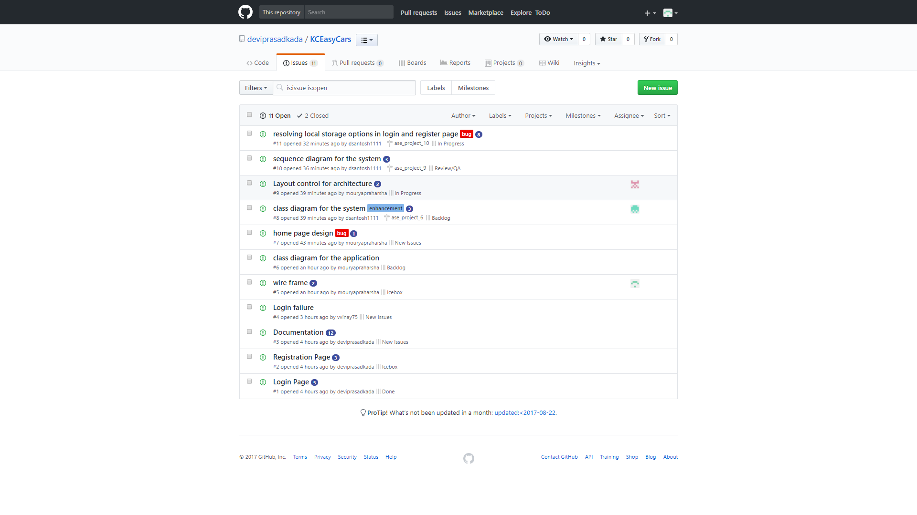

**Project Timeline, Members and Task Responsibility**

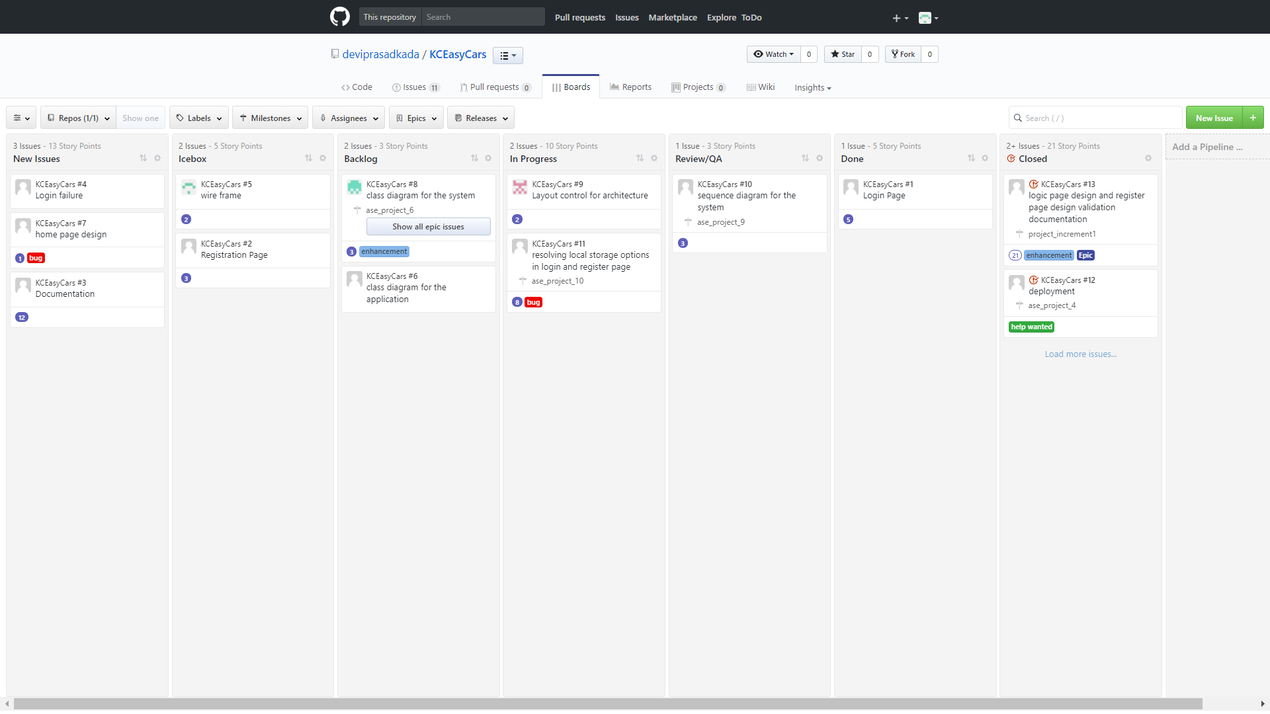

**Burn-Down Chart:**

Burn-Down chart is created for the above issues via Milestones in github

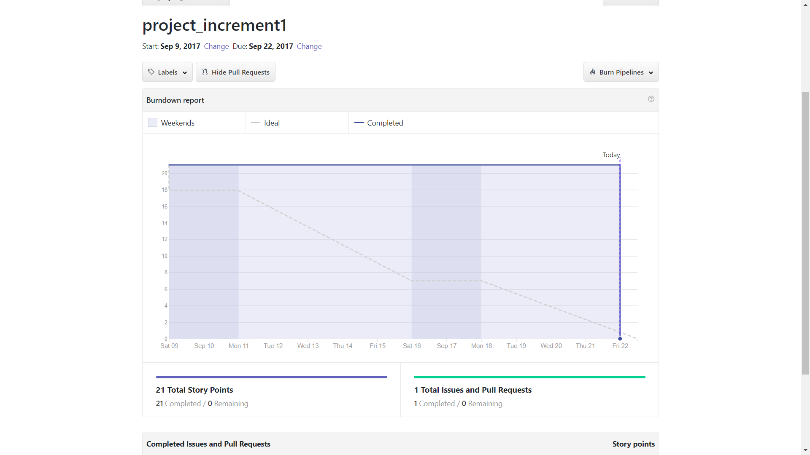

**4. Final Increment Report**

**Existing Services/ REST API**

**API’s Used**

**Facebook API:**

We have integrated Facebook API in our login page using O Auth 2.0 security. Users can easily login into our web application using their existed Facebook account. They can also register in our web application if they don’t want to use their google and facebook login

**HTML, CSS, BOOTSTRAP:**

We have used HTML, CSS, Bootstrap in our login, registration pages for designing our web pages.

**Detail Design of Features (using tools)**

**Wireframes:**

**Login page wireframe:**

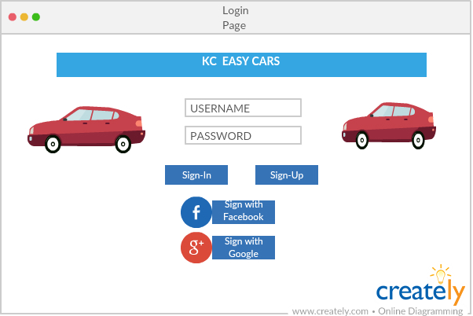

**Registration page wireframe:**

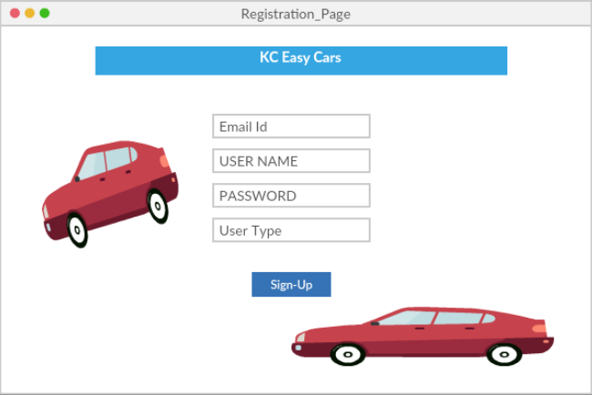

**Home page wireframe:**

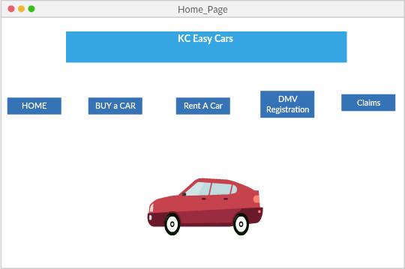

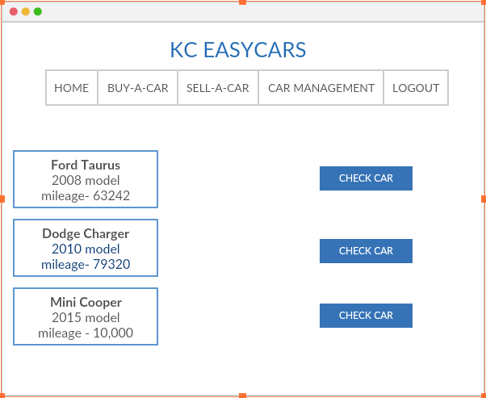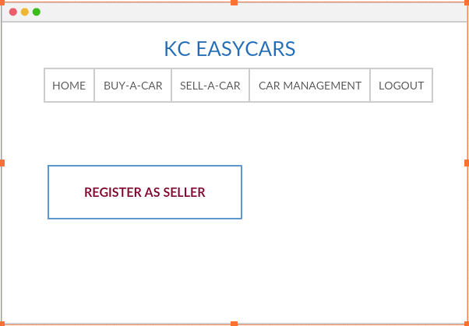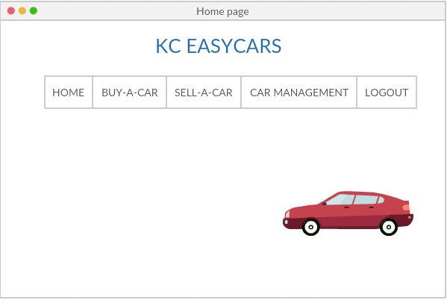

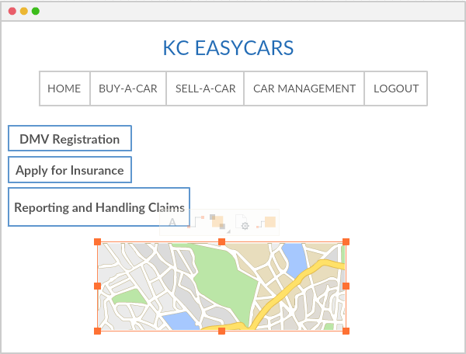

**Class Diagram:**

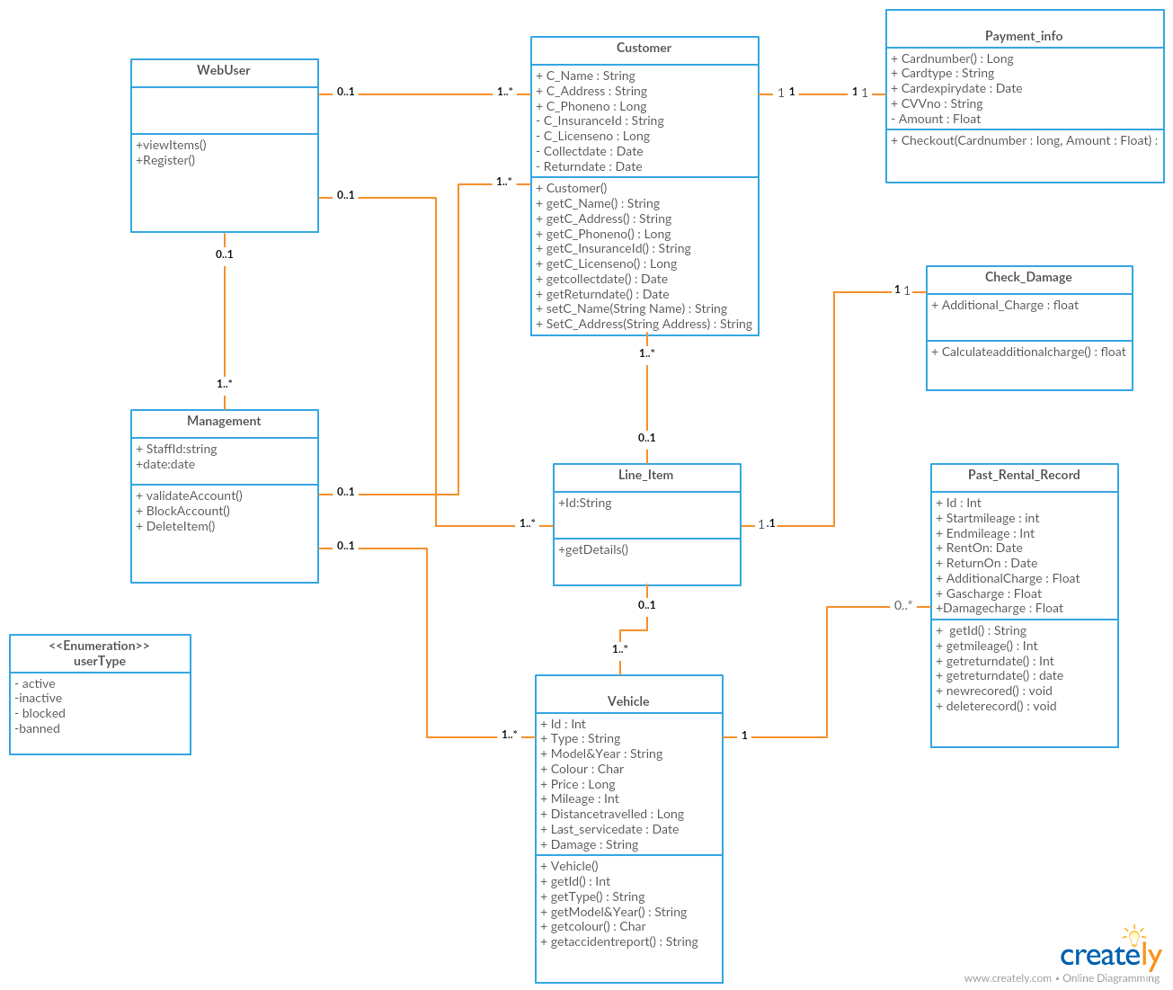

**Use case Diagram-I:**

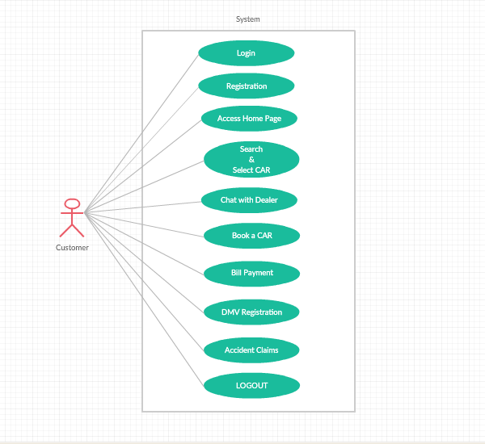

**Use case Diagram-II**

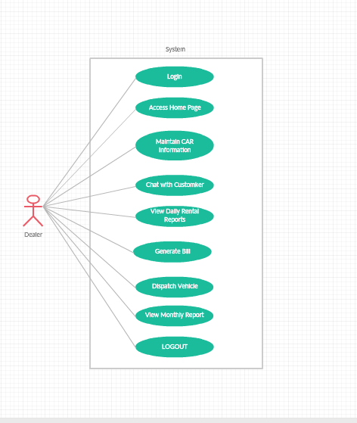

**Sequence Diagram:**

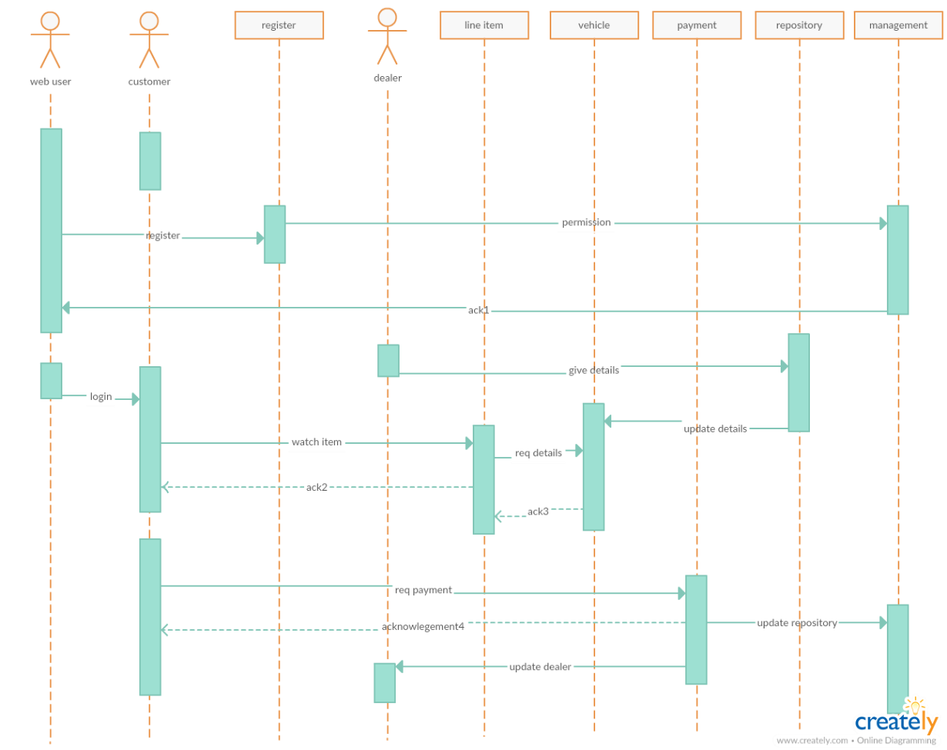

**Architecture diagram:**

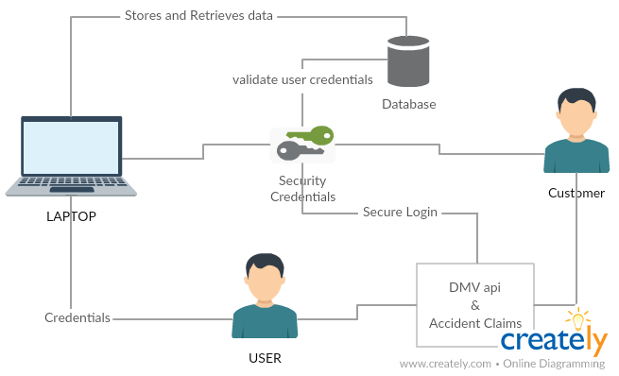

**User Stories:**

User can do many things in our web-application besides login and registration. Below are some things a user can do.

|  |  |  |
| --- | --- | --- |
| **A** | **Can** | **So** |
| User | Filter his/her search for a favorite car. | He/she gets a car based on their preference. |
| User | Chat with the dealer directly. | Dealer can reserve the car for that particular user. |
| User | Search for nearby car dealers. | That user can easily find a car near to his location. |
| User | Search for DMV registration. | User can get the guidelines of what to do after buying a car. |
| User | Information regarding reporting and handling accident claims. | User need not to worry about how to make reporting and claims. |

**Unit testing:**

**Test cases for login and signup pages:**

|  |  |  |  |  |
| --- | --- | --- | --- | --- |
| **Case** | **Test case Description** | **Expected Result** | **Actual**  **Result** | **Pass/ Fail** |
| login | Invalid Userid and password | Warning message should pop-up stating invalid credentials | Warning message should pop-up stating invalid credentials | Pass |
| Login | Incomplete details entered | Warning message pop-up stating empty credentials. | Warning message pop-up stating empty credentials. | Pass |
| Login | Valid Userid and password | Redirect to home page | Redirect to home page | Pass |
| SignUp | Must satisfy emailID format | Warning message pop-up stating invalid emailId format | Warning message pop-up stating empty credentials. | Pass |
| SignUp | Password and Confirm Password should be same | Warning message pop-up stating passwords doesn’t match | Warning message pop-up stating empty credentials. | Pass |

**5. Implementation and Deployment**

Implement and Deployment of our web application is done and the screen shots are mentioned below.

The Home page of our web application screenshot is attached below.

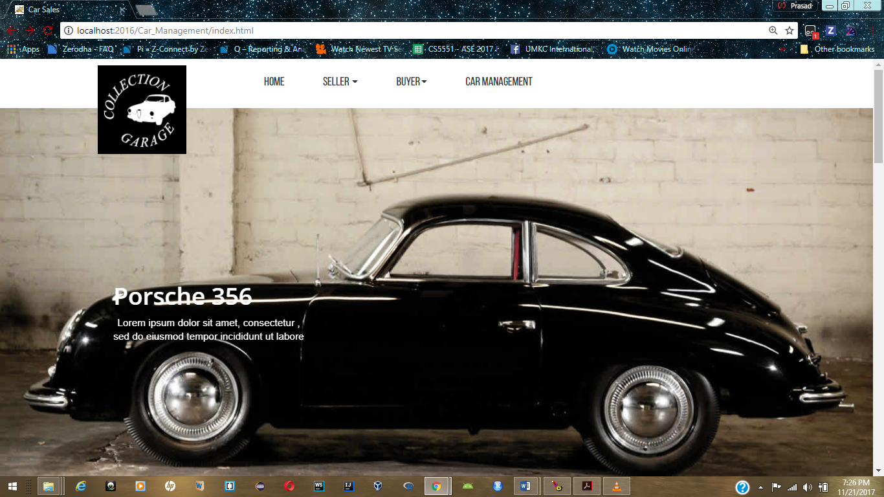

**Home page with seller, buyer and car management tabs:**

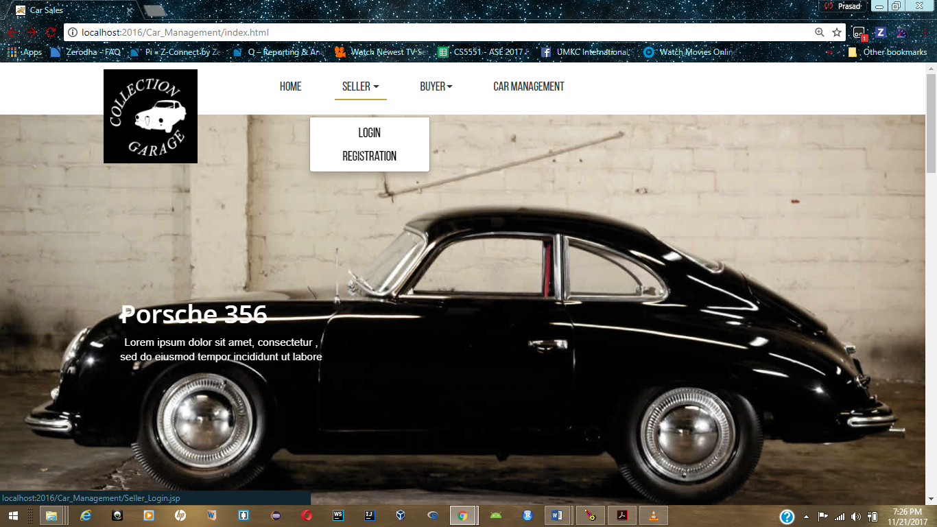

**Seller Registration:**

This Sell-A-Car page can be accessed only if the user is registered as seller so the user must be first registered as seller in order to upload a car for selling in which the user gets the message when a buyer is interested:

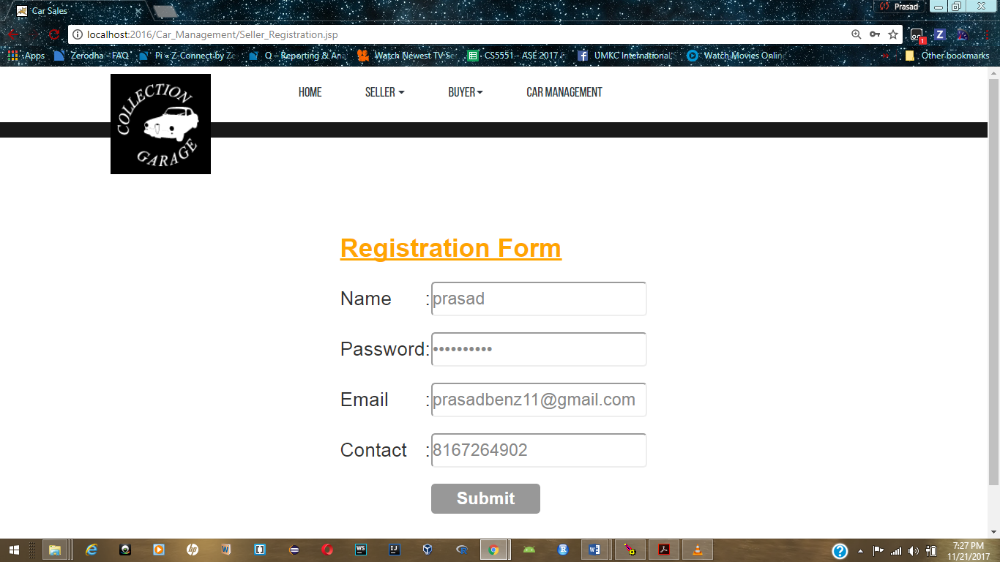

**Seller Registration Successful:**

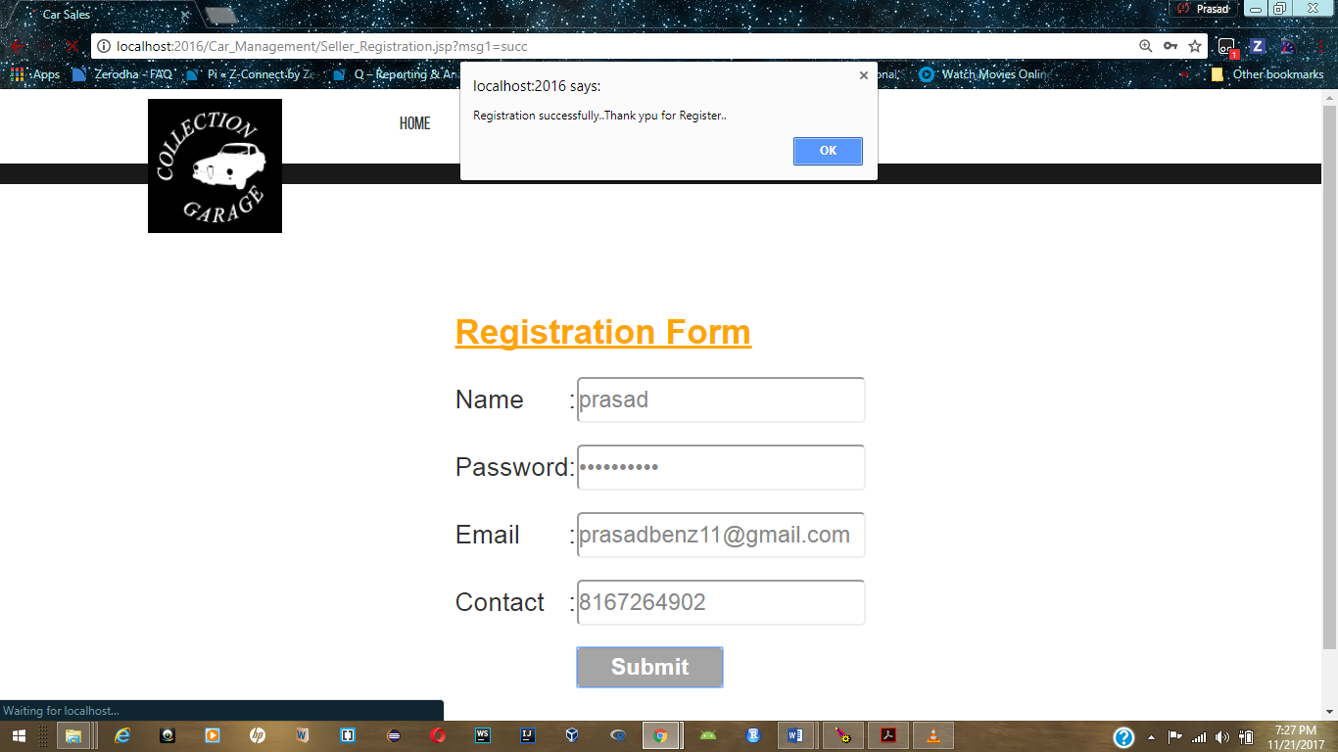

**Seller Login Page:**

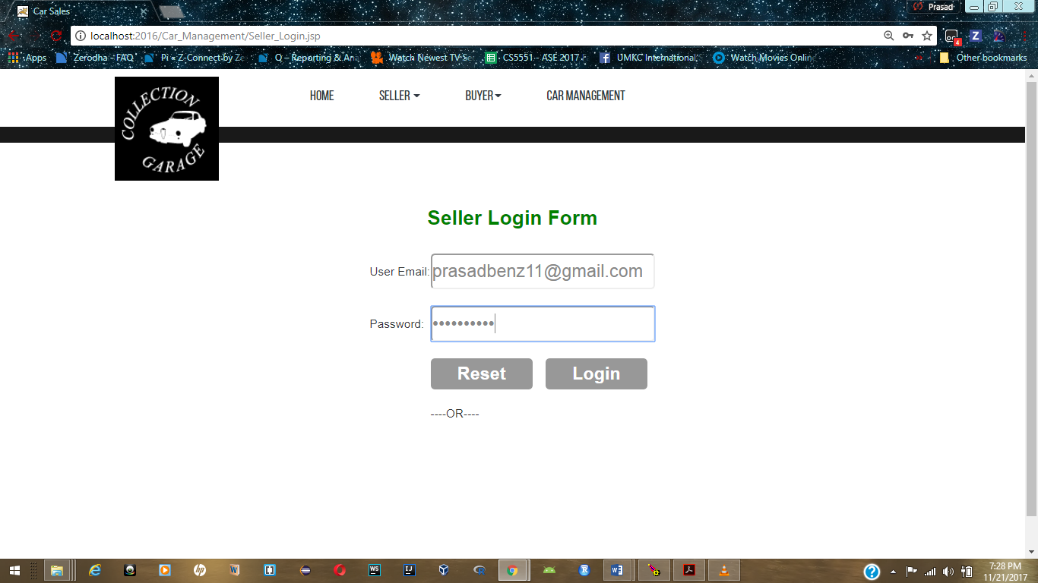

**Seller login Page success:**

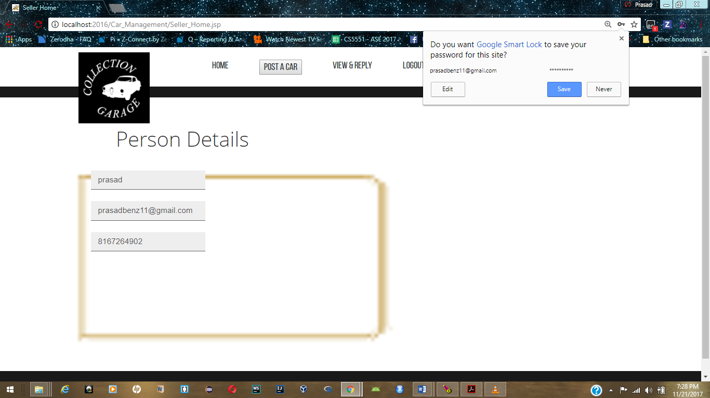

**Car Management Guidelines:**

**And finally this is the Car Management page in which the user has all the instructions and facilities to be done after buying a car. This page helps the user to know the instructions in a single page of all the required steps after purchasing a car:**

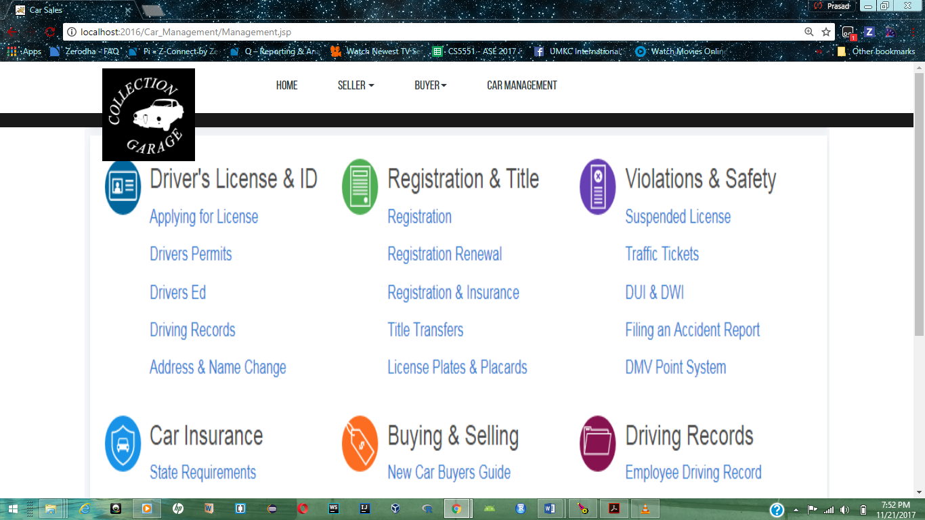

**Buyer Registration:**

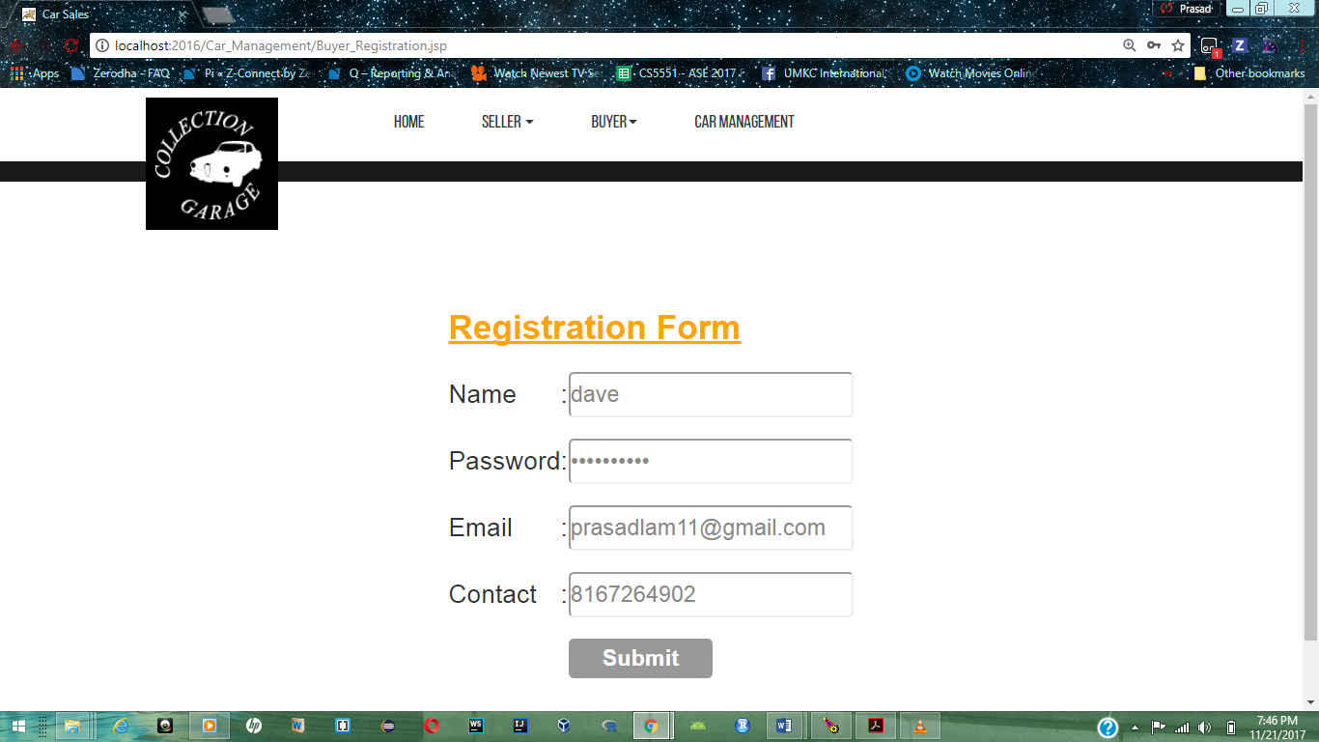

**Buyer registration successful:**

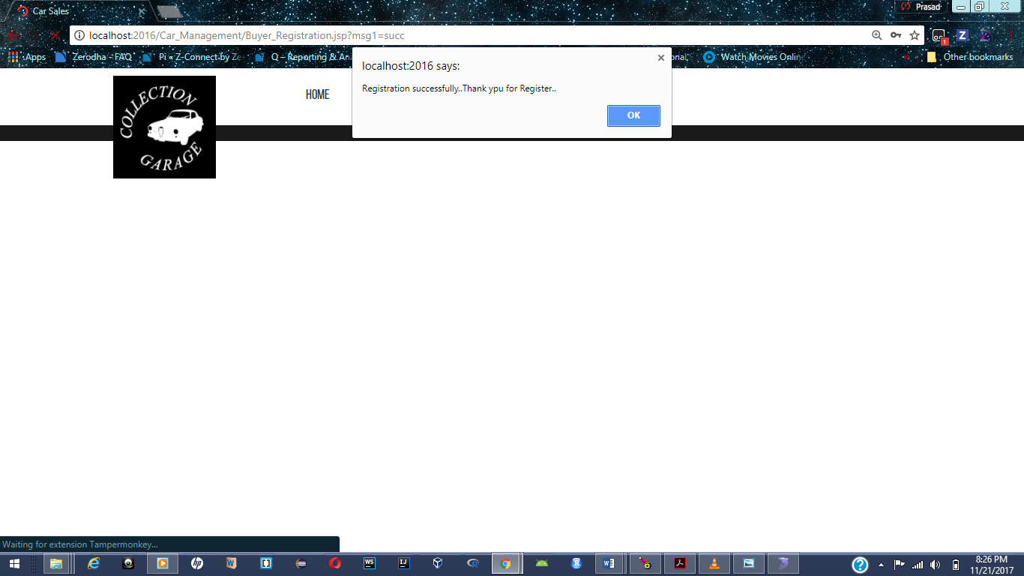

**Buyer Login Success:**

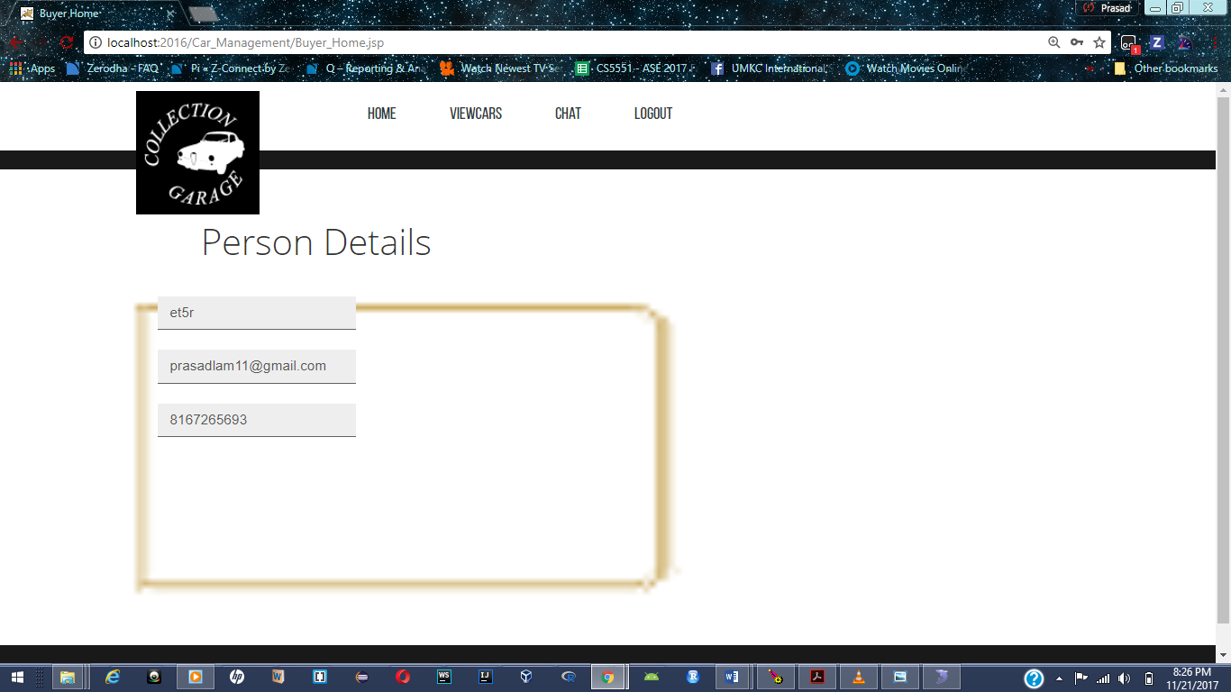

**Buyers Available list of cars: Page which contains the details of the cars which are on sale**

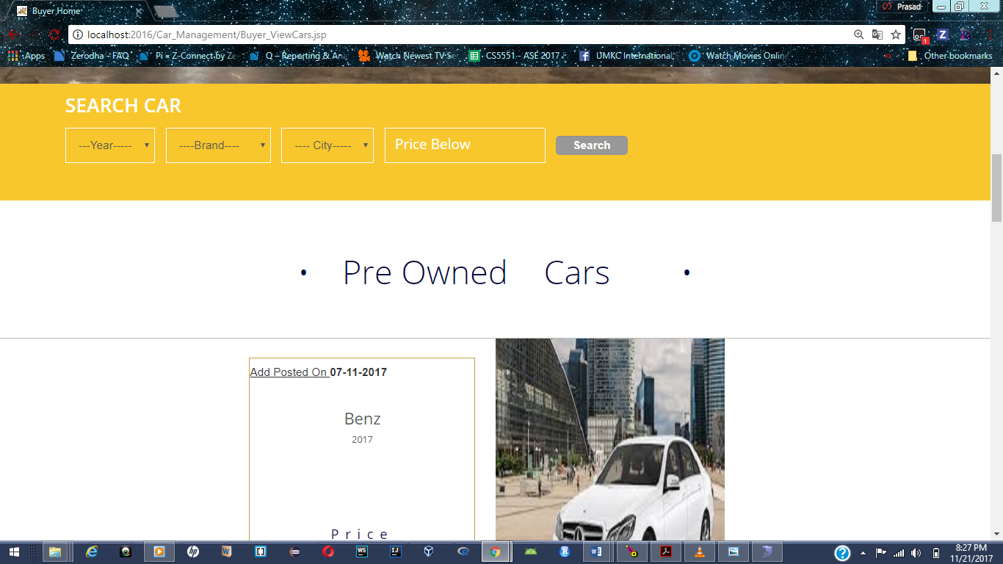

**Buyers Cars:**

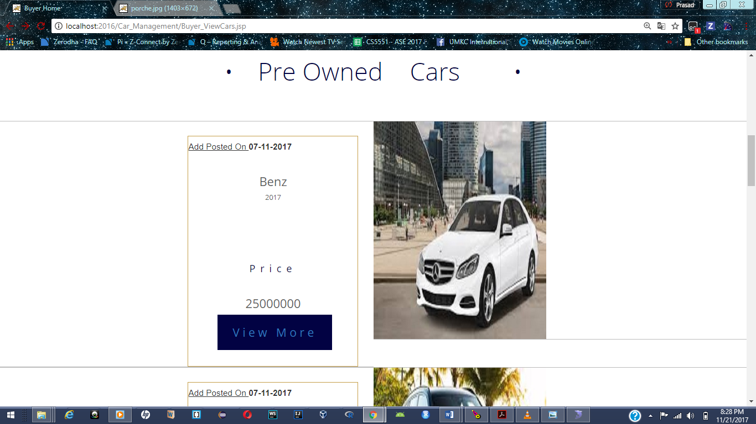

**Available cars for buyer:**

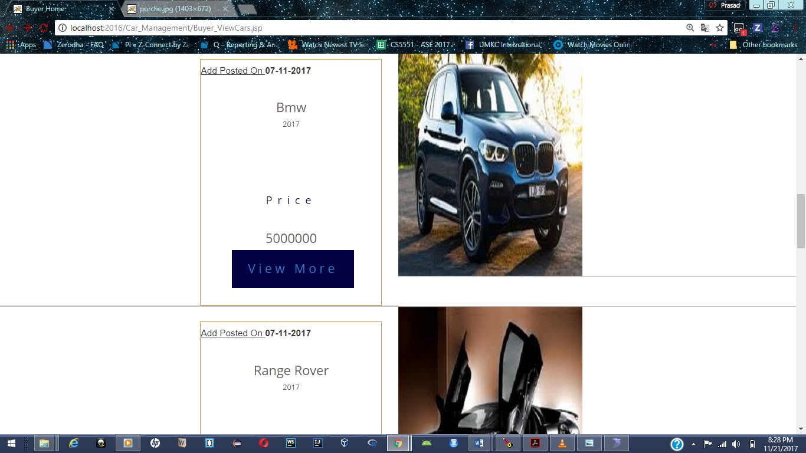

**Buyer making a deal with seller about a car:**

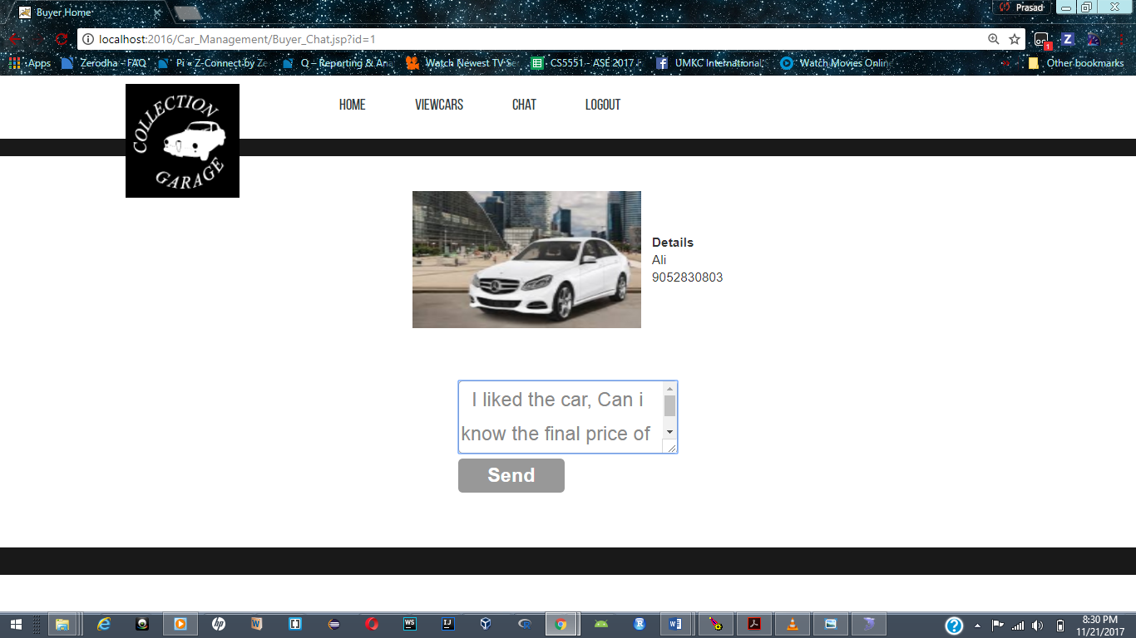

**Car Management:**

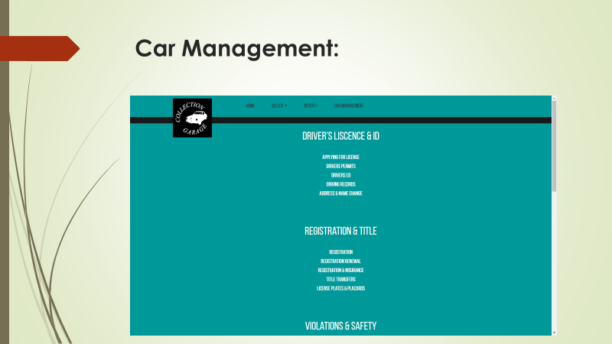

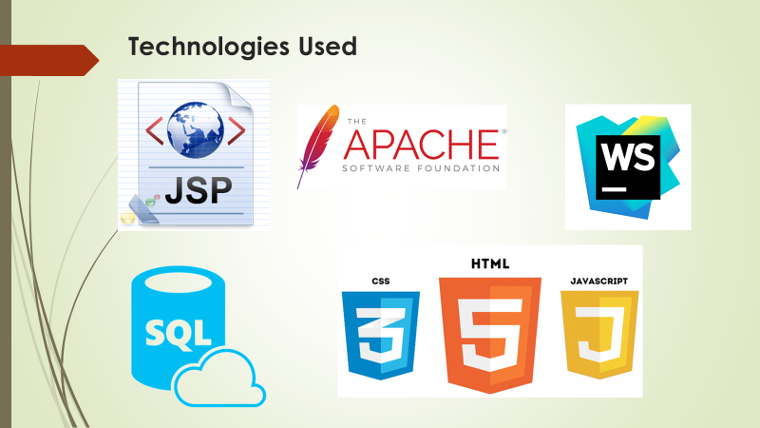

**GITHUB URL:**<https://github.com/deviprasadkada/KCEasyCars/wiki>

**YOUTUBE URL:**<https://www.youtube.com/watch?v=U0YMUj9TWO8>

**6.Project Management**

**Implementation Status Report:**

**Technologies used:**

The technologies used so far in developing or web application are mentioned below. By collaborating with various technologies together we have come up with this web application.

* HTML5
* CSS3
* BootStrap
* JavaScript
* AngularJS
* SQL Database
* Tomcat server

**Work Completed:**

The completed tasks in this increment are:

**Description:**

* Implement and deployment of Login and Register pages of seller and buyer.
* Sign-in using Google and Facebook APIs.
* Architecture of our application is defined.
* Guideline services to registration process.
* Guidelines Services for reporting and handling accident claims.
* Home page containing details about the following:

1. Home Page : Contains basic information about the project and the main motto.
2. Buy-A-Car Page : This Page is to view the cars that have been posted by the sellers with the basic details such as mileage, year of purchase and price of each car.
3. Sell-A-Car Page : This page is for the users to register as seller and sell a car.
4. Car-Management Page : This Page contains the information about the steps after purchasing the car and related sites.

**Contributors:**

* Devi vara Prasad Kada—25%
* Santosh Gandhi Diddi—25%
* Mourya Praharsha Bobbili—25%
* Vinay Chandra Vasamsetti—25%

**Responsibility and Time Taken:**

* Wireframes---------------------------------Mourya , Santosh( 1 ½ hrs)
* Home page----------------------------------Santosh, Prasad(1 ½hr)
* Login Page-----------------------------------Santosh, Vinay( 1 ½hr)
* Registration Page--------------------------Mourya, Prasad(1 ½ hrs)
* User Interface------------------------------Vinay, Prasad (1 ½hrs)
* SQL Database storage--------------------Prasad, Vinay (1 ½hr)
* Buy-A-Car Page----------------------------Vinay, Santosh(1 ½ hr)
* User Stories---------------------------------Mourya, Santosh(1 ½hr)
* Unit Test cases-----------------------------Prasad, Vinay(1 ½hr)
* Project Increment Report---------------Prasad, Mourya (1 ½hrs)
* Sell-A-Car Page-----------------------------Prasad, Mourya(1 ½hrs)
* Car-Management Page-------------------Santosh, Mourya(1 ½hrs)

**7.Bibliography**

1. [www.creately.com](http://www.creately.com)
2. [www.bootstrap.com](http://www.bootstrap.com)
3. [www.bootsnipp.com](http://www.bootsnipp.com)
4. [www.angularjs.org](http://www.angularjs.org)
5. [www.developers.facebook.com](http://www.developers.facebook.com)
6. [www.console.developers.google.com](http://www.console.developers.google.com)
7. [www.developers.facebook.com](http://www.developers.facebook.com)
8. <http://tomcat.apache.org/>